|  |  |
| --- | --- |
| **Installed capacity** | 51 kWh |
| **Battery technology** | LiFePO4 |
| **Battery lifetime** | ≥3500 cycles |
| **Battery heating** | Electric 380 W, to enable full charging capacity even at low temperatures |
| **Battery voltage** | 460-555 V |
| **Battery cell protection** | Balancing, voltage control on each cell, temperature control |
| **Battery pack protection** | Fully protected against overcurrent, over- and undervoltage, over temperature, leak detection |
| **Nominal discharge current** | 50 A |
| **Control interface** | CAN, analogue and logic I/O |
| **Charging** | Mobile charger 11 kW, 3*400V AC standard 3*16A CE plug |
| **Charging time** | 5-6 hours |
| **AC installation requirements** | 3 phases, neutral and PE, 3x400 VAC, 50 Hz, 16 A fuses with RCD |
| **+24 V supply from Body or Chassis** | 24 VDC, 15 A normal automotive fuse. |
| **Temperature range** | -20°C to +45°C (above +35°C derating). Below 0 ̊C only with heating |
| **Cooling** | Battery Pack - N/A, Mobile charger – forced air |
| **Enclosure** | IP55 |
| **Dimensions (L x W x H)** | • Battery Pack – 375x1365x811  • Mobile Charger – 565x730x1256 |
| **Weight** | • Battery pack unit: 520 +/- 50 kg  • Mobile Charger unit: 40 +/-10 kg |

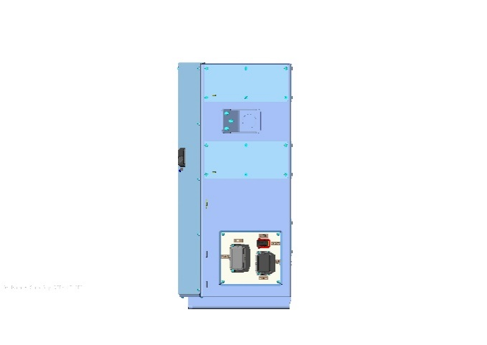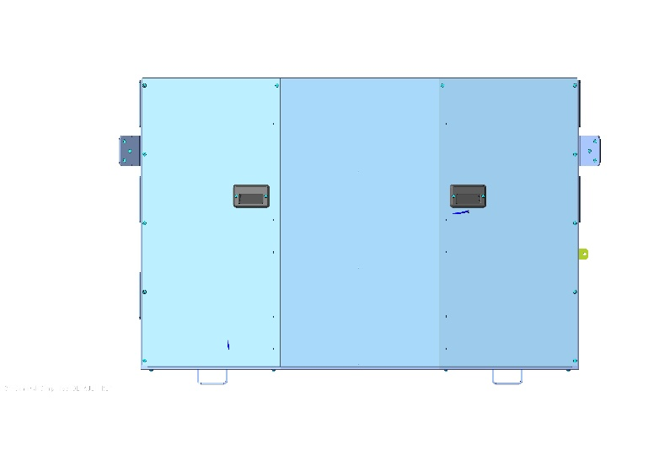

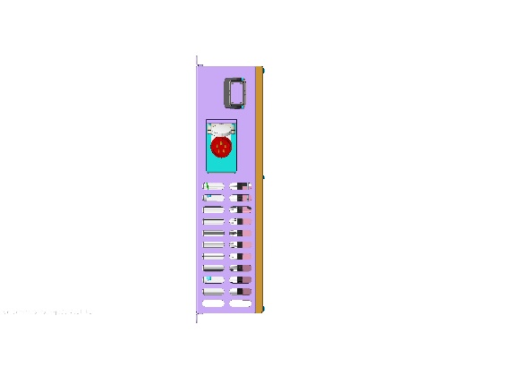

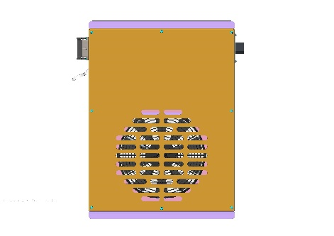

Battery pack view Mobile charger view